Pay Gap Report
Published March 2024
Cambridgeshire County Council is an employer with over 250 employees therefore required by law to carry out Gender Pay Reporting under the Equality Act 2010 (Gender Pay Gap Information) Regulations 2017. This involves carrying out calculations that show the difference between the average earnings of men and women in our Council; it will not involve publishing individual employees’ data. The data used for the calculations is the Council’s pay data as of 31st March 2023.
We are required to publish the results on a government gender pay gap website, and in addition we publish the high-level results on the Cambridgeshire County Council website alongside our pay and transparency data.
Gender pay reporting is used to assess:
- the levels of gender equality in our workplace
- the balance of male and female employees at different levels

Although not a legislative requirement, we have also chosen to publish our ethnicity pay gap and have included recommendations as a result of the figures into the action plan below.

Few employers in Cambridgeshire can boast the breadth and variety of roles we enjoy at Cambridgeshire County Council. With over 4600 employees, we are one of the biggest employers in the County, with a diverse workforce to be proud of.

Gender Pay Gap
Our Workforce Profile
The headcount for CCC was 4282 on 31st March 2023 (the snapshot date). The number of positions filled at CCC is higher due to some employees holding more than one position, a total of 4668 positions.

For the purpose of this data 3917 employees were considered ‘full time relevant employees’ under the government gender pay gap reporting guidelines.

Measure | Information
Number of employees | 3917 employees*
Number of employees | 802 male (21%) | 3115 female (79%)
Mean | 10.09%
Median | 8.38%
Pay quartiles | Male |  | Female
Lower | -0.5% | 144 | 835
Lower middle | +0.5% | 184 | 795
Upper middle | +0.5% | 218 | 761
Upper | +5.5% | 256 | 724
Mean, median and proportion of employees receiving a bonus payment | Cambridgeshire County Council does not operate a bonus payment scheme, and therefore has no bonus payment pay gaps.
*Our headcount was 4282. The number of positions filled at CCC is higher due to some employees holding more than one position, a total of 4668 positions. For this data, 3917 employees were considered ‘full pay relevant employees’ under the government gender pay gap reporting guidelines. From the employees considered within this report, 210 are apprentices. Please note that these figures exclude employees on reduced pay such as absence/maternity and adoption leave/career breaks, and therefore does not correspond to the total headcount figure.

Mean Gender Pay Gap in Hourly Pay
As of 31st March 2023, the mean hourly rate for roles held by males was £19.03 and £17.11 for roles held by females (Figure 2). This means on average roles held by males earned £1.92 more per hour than roles held by females, which equates to a mean difference of 10.09%. In comparison to last year’s figures, we have seen a slight increase of 1.26%.
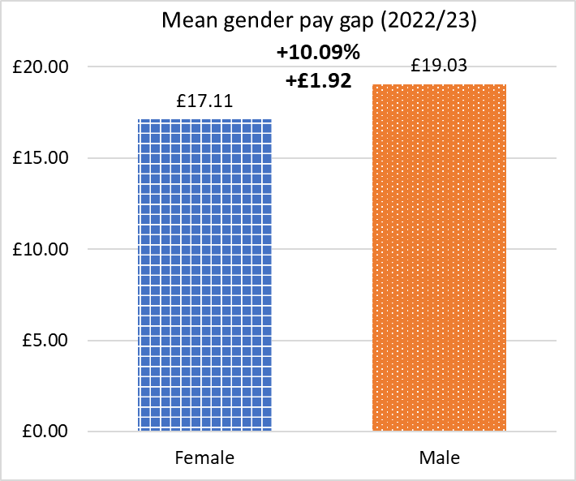
Median Gender Pay Gap in Hourly Pay
Our median hourly rate for roles held by males is £17.06 and for £15.63 for roles held by females with an hourly difference of £1.43, meaning an 8.38% difference. From a statistical point of view the median is a more accurate measure as it is not affected by the top and bottom of the pay scales (outliers) which can vary from £195,700 down to £21,571. We have experienced an increase of 0.22% to our median gender pay gap since 2022.
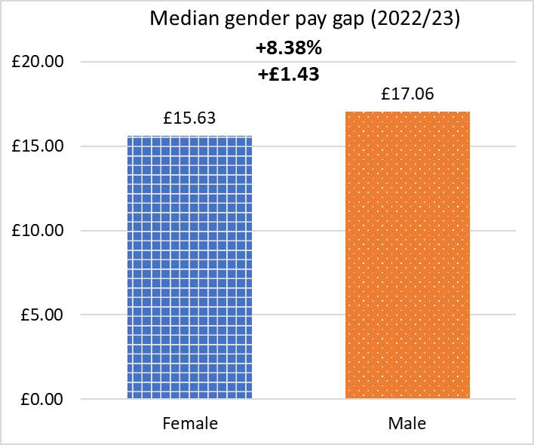

Proportion of Males and Females in Each Pay Quartile
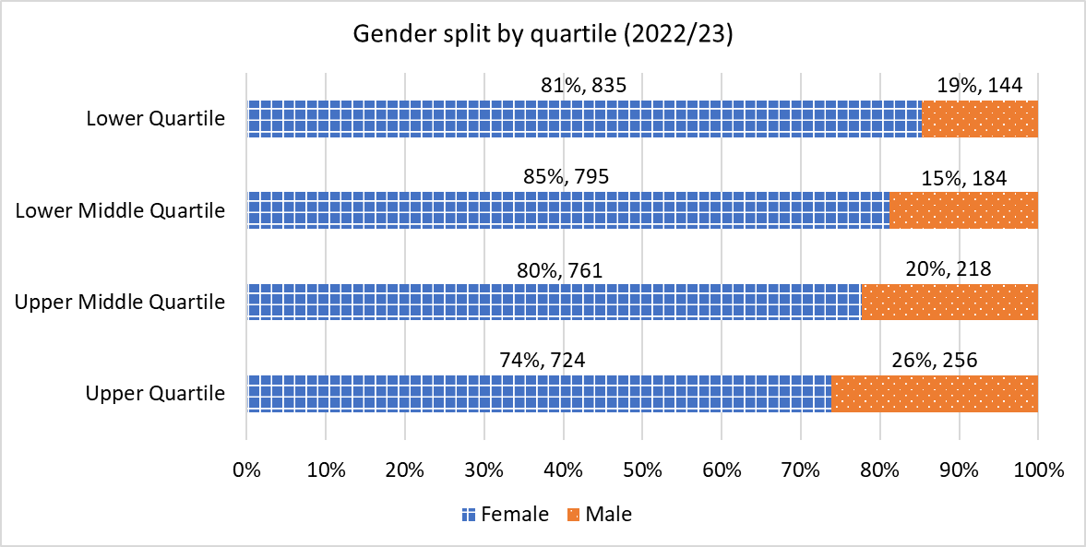
The graph above outlines the gender split by pay quartile and illustrates the quartile split by percentage and employee numbers. The number of employees that were included (full pay relevant employees) in this year’s Gender Pay Gap Report is slightly lower than last year.
The hourly rate range of the lower quartile is between £10.53 - £12.24, the lower middle quartile is £12.24- £15.63. The upper middle quartile is hourly rates of £15.63 - £20.23. The upper quartile relates to hourly rates from £20.23 up to £98.49, this includes the Leadership pay scale. Where there were employees on the same hourly rate that overlap between the top or bottom hourly pay of the quartiles men and women have been split as evenly as possible across the hourly pay quartiles, either side of the overlap.
Please note that these figures exclude employees on reduced pay such as absence/maternity and adoption leave/career breaks, and therefore does not correspond to the total headcount figure.
Since last year the two lower quartiles have seen an 11% increase with the upper middle increasing by 7% and the upper quartile by 5%. These increases are related to our cost-of-living increases and real living wage increments.

Mean, Median and Proportion of Employees Receiving a Bonus Payment
Cambridgeshire County Council does not operate a bonus payment scheme, and therefore has no bonus payment pay gaps.

Ethnicity Pay Gap

Until such a time that ethnicity pay gap reporting becomes legislative, there is no agreed calculation or classification for the data. We have, therefore, calculated our ethnicity pay gap in a similar format to the gender pay gap process, comparing the number of employees disclosing they are of an ethnic origin other than white, against the earnings of employees who are white and excluding those who have opted to ‘prefer not to say’ or who have not disclosed any information on their ethnicity. The method in which we report the ethnicity pay gap may differ in the future if legislative requirements and guidance are introduced.
Ethnicity pay reporting is voluntary and it allows us to identify and investigate disparities in the average pay between ethnic groups to inform action. Nationally, the Office of National Statistics found in 2019 that some ethnic minority groups earn less per hour than white British employees on average, while others earn more.
As of 2023, our mean ethnicity pay gap is 5.6% compared to 2022’s figure of 3.1% and our median ethnicity pay gap is 5.8% compared to 6.2% in 2022; the calculation of the hourly rate of employees of an ethnic origin other than white, compared against those declaring they are white.
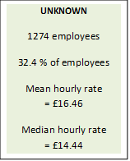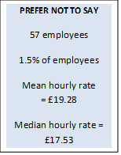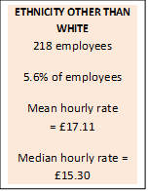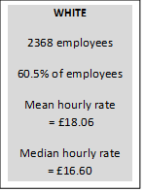
Ethnicity Pay Gap
The ethnicity pay gap is the calculation of the hourly rate of employees of an ethnic origin other than white, compared against those declaring they are white.
Mean Ethnicity Pay Gap  5.6% | Median Ethnicity Pay Gap  5.8%

The data above demonstrates that that those employees of an ethnic origin other than white are earning an average of £0.95 less, per hour, than white employees and have a lower median hourly rate. However, those who have declared their ethnicity as other than white equates to only 5.56% of the council.
It is also worth noting that employees who have not disclosed their ethnicity details to us have an average lower hourly rate. Having further information on ethnicity will help to determine the true mean and median gender pay gap.

Action We Are Taking

Our current workforce data tells us that the council is attracting and retaining women and we have a fairly representative number of female employees across all four pay quartiles. The council has a fair and equitable pay policy in place and promotes flexible working practices. All jobs in the council are evaluated using the Hay methodology to ensure we have equality of grading for all colleagues carrying out the same work.
We are committed to continuing to make meaningful change, exploring how we can diversify our workforce, promote and encourage flexible working and publish clear and transparent progression routes, particularly for underrepresented groups. Actions included in our EDI and People Strategy action plans include:

THEME | ACTIONS WE WILL TAKE
Attracting you | - Ensure an unbiased approach to starting salaries and ensuring that the advice provided by the HR and Recruitment Teams, and recruitment training for managers is clear.  - Explore ways to break the unconscious bias and encourage/ attract more of each sex into roles where the balance is heavily weighted to one or other.  - Following on from our staff survey we will highlight the positive perception of our approach to flexible working to showcase Cambridgeshire that will support them to balance their work and life.  - Review the existing recruitment training and provide updates related to inclusion (EDI strategy action plan), including highlighting current disparities in appointments above the bottom of the grade to raise manager awareness.  - Develop a Recruitment eLearning package and ensure EDI is woven throughout (EDI strategy action plan)
Supporting you | - Review the outcomes of the 2023 employee engagement survey, using any relevant demographic themes to inform activity supporting the reduction of our gender and ethnicity pay gaps, particularly perceptions of fairness in opportunities to progress.  - Continue to raise awareness of the importance of disclosing diversity data for employees and be clear why this information is required. Use the ERP off network project to drive this.  - Use insights from the newly launched Anti-Racism Steering Group to better understand racial inequities in the workplace, engage with ethnic minority colleagues and identify actions to address any issues identified.
Appreciating you | - Identify further steps in recognising/celebrating success - we have launched the Spotlight Awards to provide an opportunity for teams to vote to shine a spotlight on people in our organisation that truly embody our vision and values.  - Continue to retain a performance pay process that recognises both behaviour and performance
Developing you | - Offer 10 places on an ILM level 5 certificate in coaching and mentoring to expand our pool of professional coaches and increase the number of coaching sessions available to colleagues.  - Evaluate the mutual mentoring pilot scheme and roll out a corporate scheme. (EDI strategy action plan).  - Review the women of colour in leadership pilot feedback and launch another cohort of the programme (EDI strategy action plan).  - Publicise current career development offers including targeting underrepresented staff groups – monitor uptake of existing career development offers by protected characteristic (EDI strategy action plan).  - Continue to monitor the diversity of our apprenticeships, showcasing diverse profiles of completed apprenticeships (EDI strategy action plan).  - Develop the professional knowledge and skills of our line managers to support our People Strategy, including their skills and confidence in having meaningful development conversations to support career progression, and providing constructive feedback to aid performance and behaviour improvement.  - Understand, using focus groups, what we are already doing well to have supported female colleagues to transition to Leadership positions and how we can apply that learning to continue to develop our future leadership cohort in a way that is reflective of the organisation.  - Increasing visibility of senior leaders as part of our People Strategy action plan could provide an opportunity for leaders to share their insights into what helped them to reach their position.

